PROJECT -1

**DC Motor Speed**

(PID Controller)

The combination of proportional, integral and derivative control action is called PID control action. PID controllers are commonly used to regulate the time-domain behavior of many different types of dynamic plants. These controllers are extremely popular because they can usually provide good closed-loop response characteristics. Consider the feedback system architecture that is shown in Fig. 1 where it can be assumed that the plant is a DC motor whose speed must be accurately regulated .

**` SOURCE CODE OF PROGRAM       **

import num.py as np

import matplotlib.py plot as plot

from sci.py import signal

# --- DC motor parameters ---

J = 0.01   # kg·m^2

b = 0.1    # N·m.s

K = 0.01   # N·m/A  (also V·s/rad)

R = 1.0    # ohm

L = 0.5    # H

# Motor transfer function G(s) = K / (JLs^2 + (J*R+L*b)s + (R*b + K^2))

Num G = [K]

Den G = [J*L, J*R + L*b, R*b + K**2]

# --- PID controller C(s) = Kds + Kp + Ki/s = (Kd s^2 + Kp s + Ki) / s ---

Kp, Ki, Kd = 100.0, 200.0, 10.0

Num C = [Kd, Kp, Ki]

Den C = [1.0, 0.0]

# Open loop: OL(s) = C(s)G(s) = N(s)/D(s)

Num OL = np.convolve(num C, num G)

Den OL = np.convolve(denC, denG)

# Closed loop with unity feedback: T(s) = OL / (1 + OL) = N / (D + N)

Num CL = num OL

Den CL = np.polyadd(denOL, numOL)

# LTI system and step response

sys = signal.Transfer Function(num CL, den CL)

t = np. linspace(0, 2.0, 1000)

t, y = signal.step(sys, T=t)

plt.figure(figsize=(10, 6))

plt.plot(t, y, label="Speed (rad/s) for 1-rad/s step")

plt.xlabel("Time (s)")

plt.ylabel("Speed (rad/s)")

plt.title("DC Motor Speed Control with PID (Sci.py only)")

plt.grid(True)

plt.legend()

plt.show()

OUTPUT

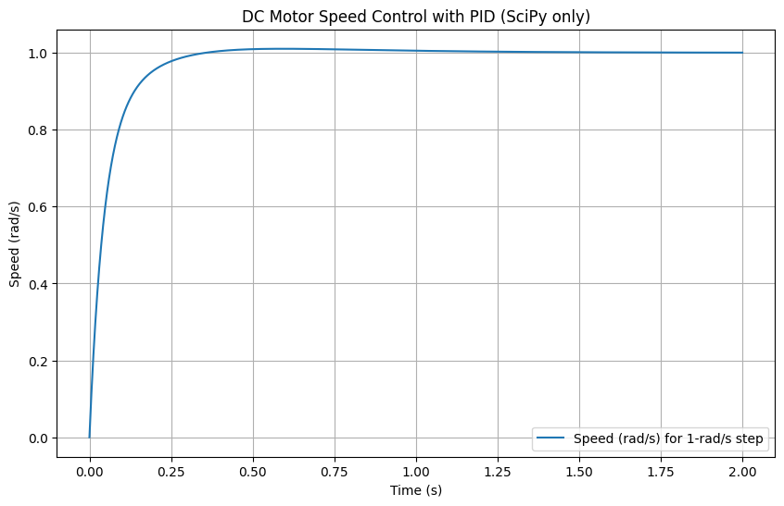

Conclusion :

Accurate motor performance is a desirable feature for any industrial application. Since engine performance deteriorates with age, it is desirable to evaluate engine performance from time to time for efficient operation. The traditional way of calculating the output power index is very time consuming